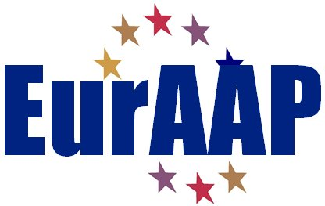

NOMINATION FORM FOR THE
2024 EurAAP Per-Simon KILDAL AWARD

Nominee
  - Name: Name
  - Professional Affiliation and Title: Affiliation & Title
  - Address:
Address.
  - E-mail: e-mail.
  - Education (Institution, location, degree, and year received)
Education.
  - Date of PhD defence: Day/Month/Year
  - List of three relevant publications related to the work of the PhD (please include them as annex)
List of publications

NOMINATOR (PhD supervisor)
  - Name: Name.
  - Professional Affiliation and Title: Affiliation & Title
  - Address:
Address.
  - E-mail: e-mail.

Endorsers (minimum 2, maximum 3)
Names, addresses, and emails

Note: the nomination form must be accompanied by:
- A nomination letter from the PhD supervisor
- An extended abstract of the PhD thesis (maximum six pages) including a list of publications (minimum 10 point font size).
- Three representative publications related to the work of the thesis

Please complete the form and send it as PDF to:
KildalAward@euraap.org

Endorsement letters may accompany the nomination or be sent separately. The nominator is responsible for submitting all the materials.

